DCL and TCL command

Save point and rollback

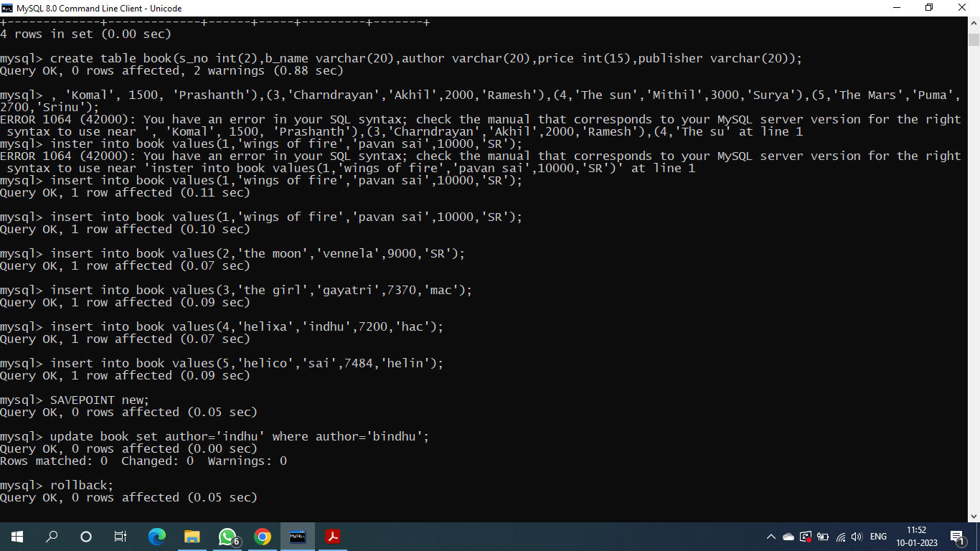

Grant command

Grant select,update on books from sai;

Revoke

Revoke insert ,select on book from sai;

Commit command

